Entering Scores and Pitch counts Sports Connect 2021

- Go to www.Pearlandlittleleague.com
- Login to your Sports connect account
- Go to your Team page
  - Quickest way is to go to “My Account” at the top of the page
  - Underneath the child you see the team they are registered to and “Visit Team Page” link, click on that

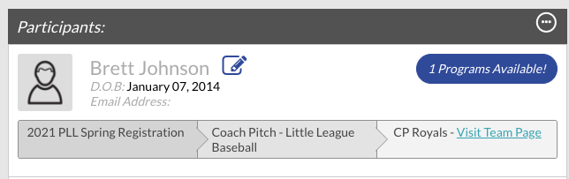

- On your team page click on “Calendar”
- Click on “Results”
- Click on “Edit Scores”
- Home Team Enter the Score and Pitch counts
- Away Team enter Pitch counts (Home team must enter the score first)
- After editing Post the score
- If there is a mistake the game must be unposted first, then edits made, then reposted.

